# **CLOUD TRAINING - AZURE FINAL EXAMINATION PART 02**

* **Initializing terraform and provider**

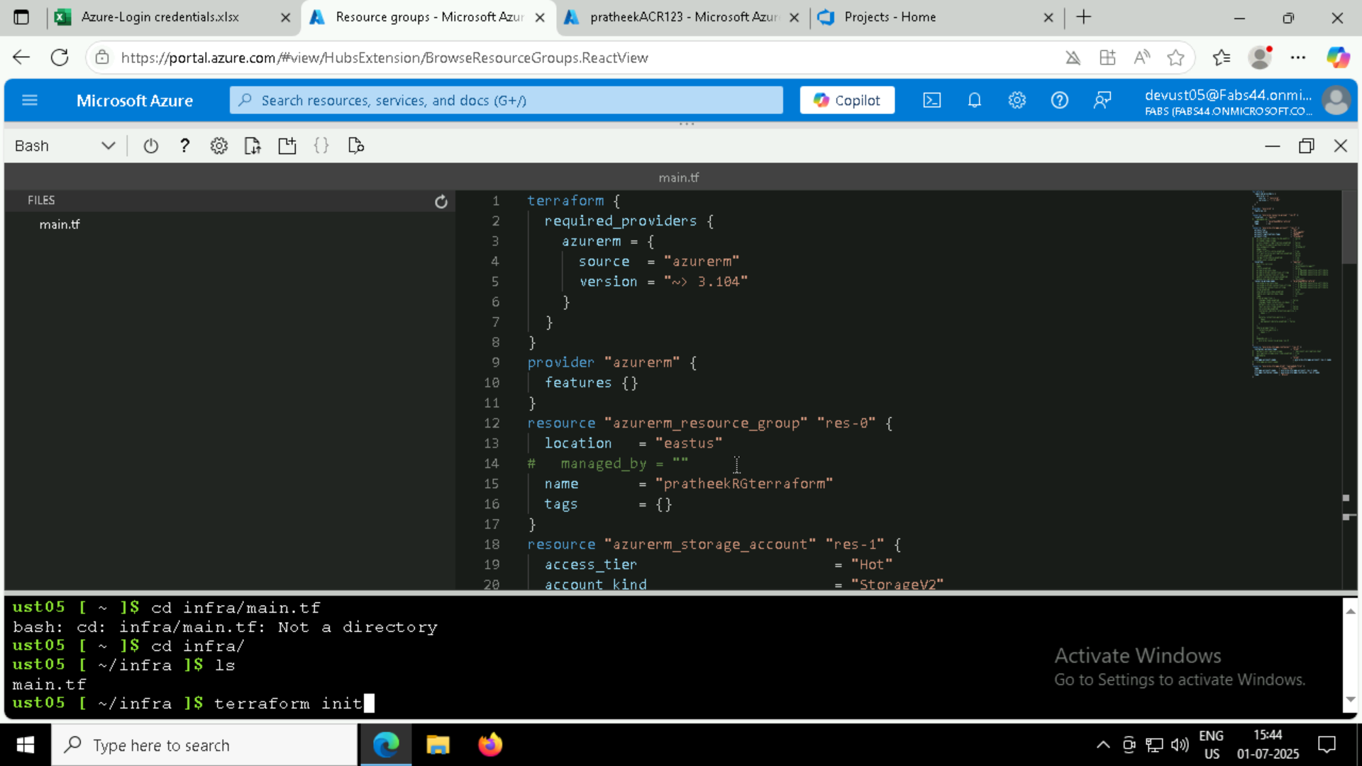

* **AZURE REPO:**

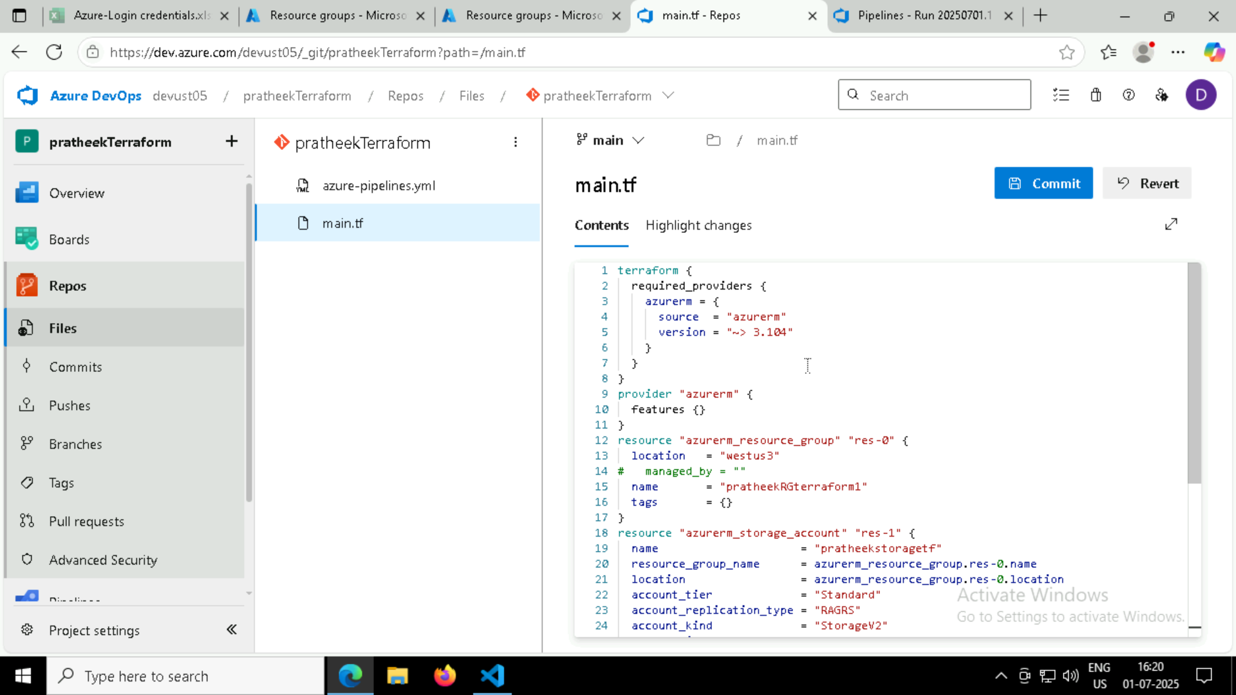

* **CREATING AZURE PIPELINE TO RUN TERRAFORM SCRIPT:**

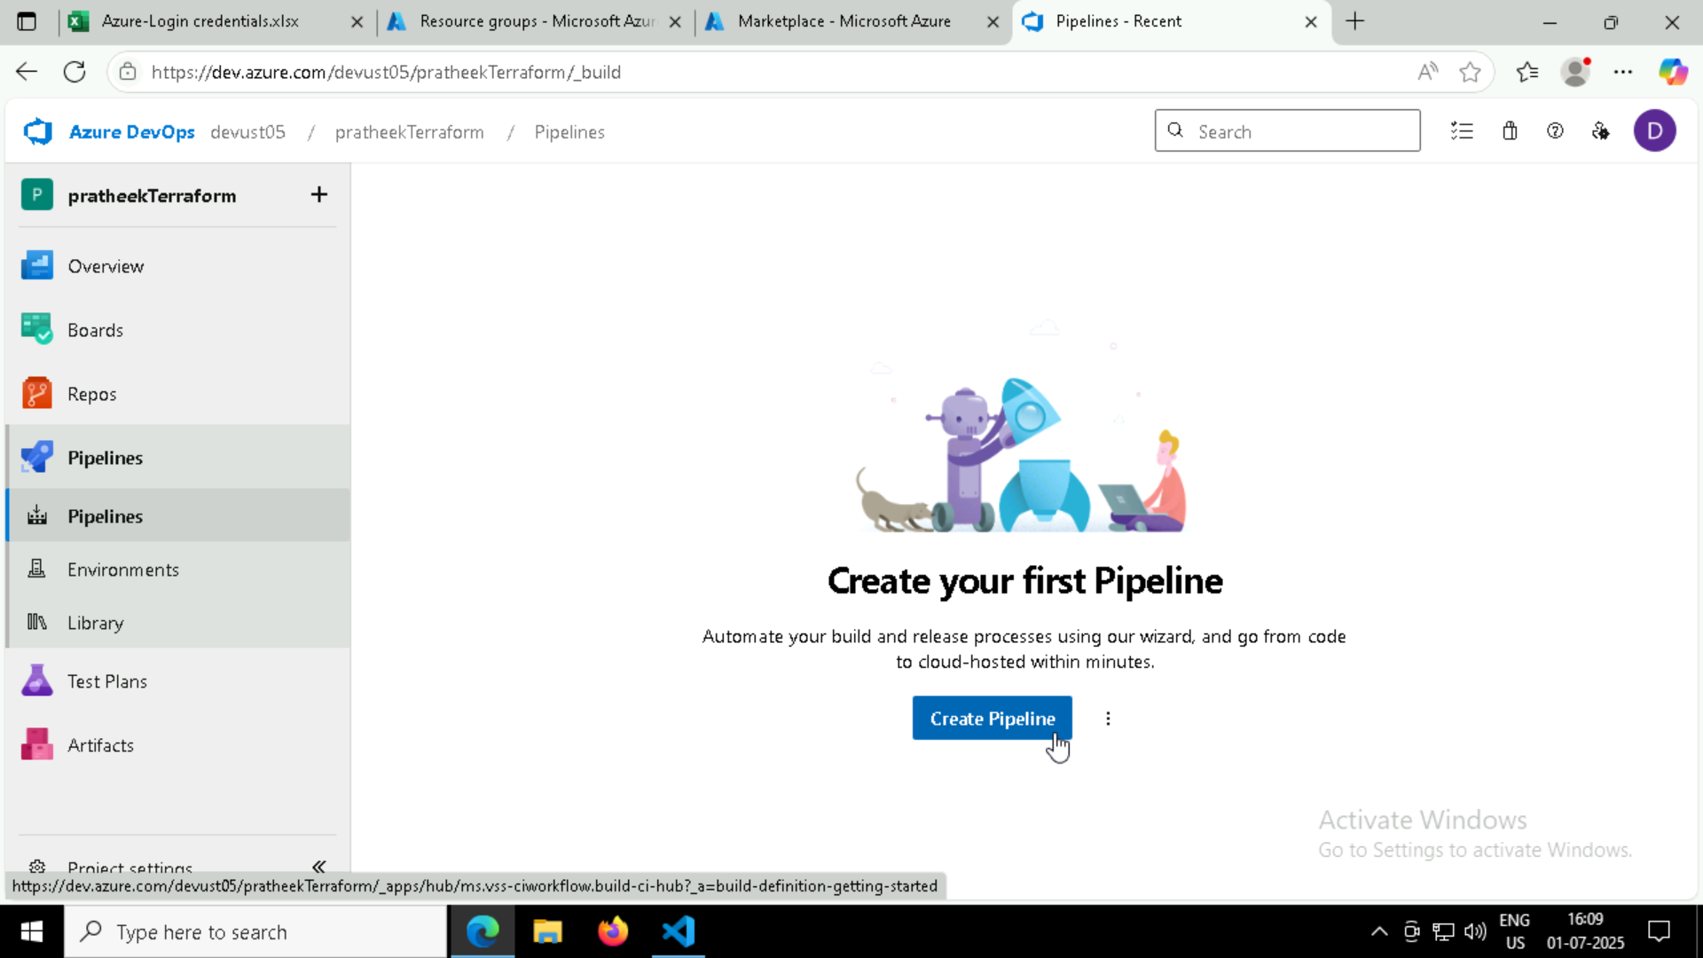

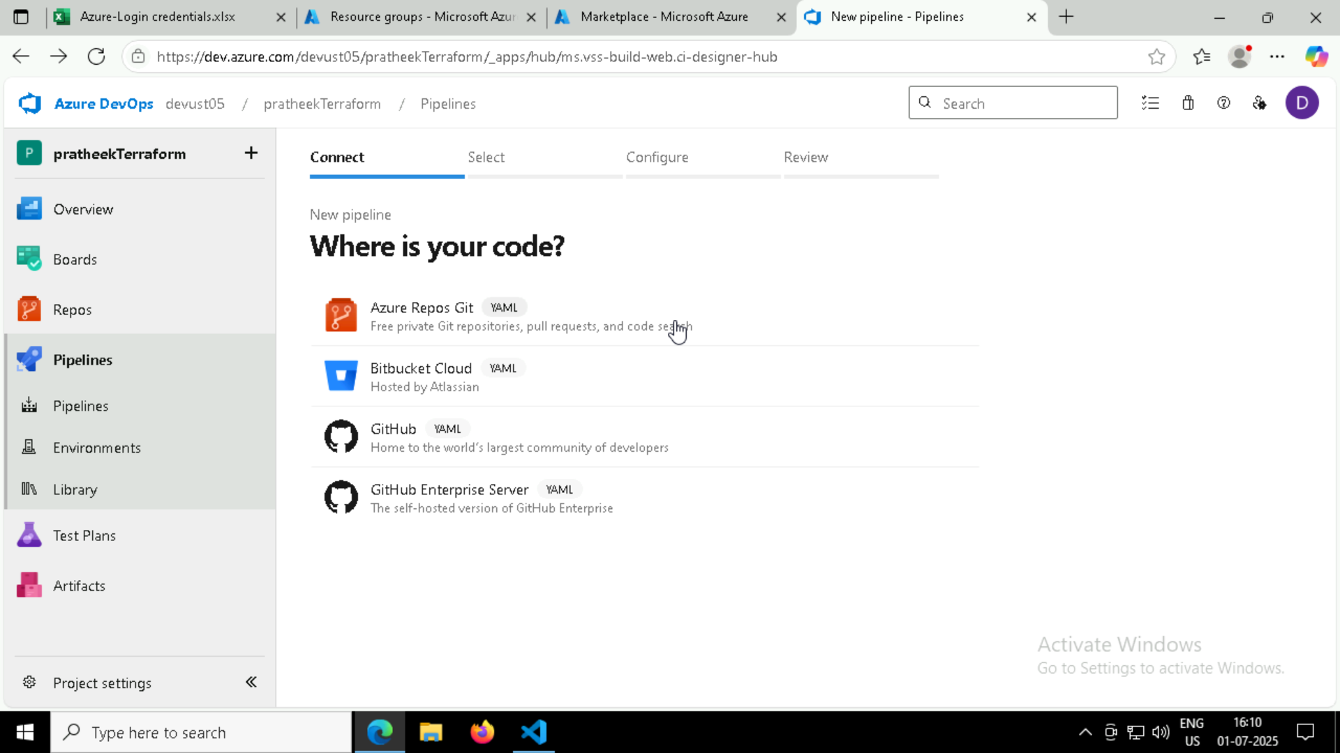

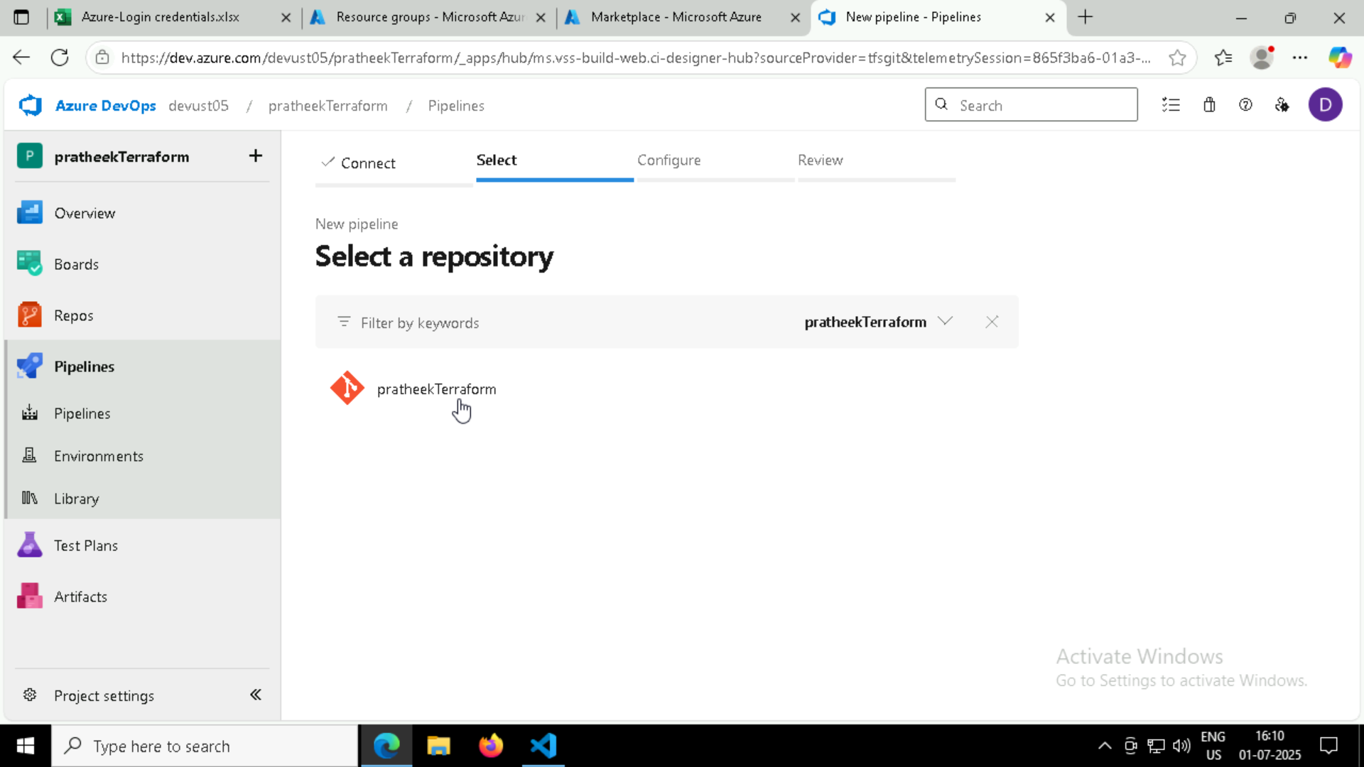

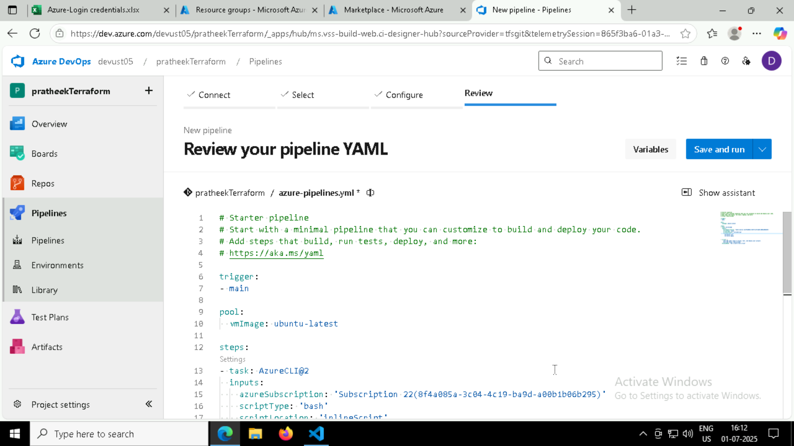

* **My pipeline.yml script:**

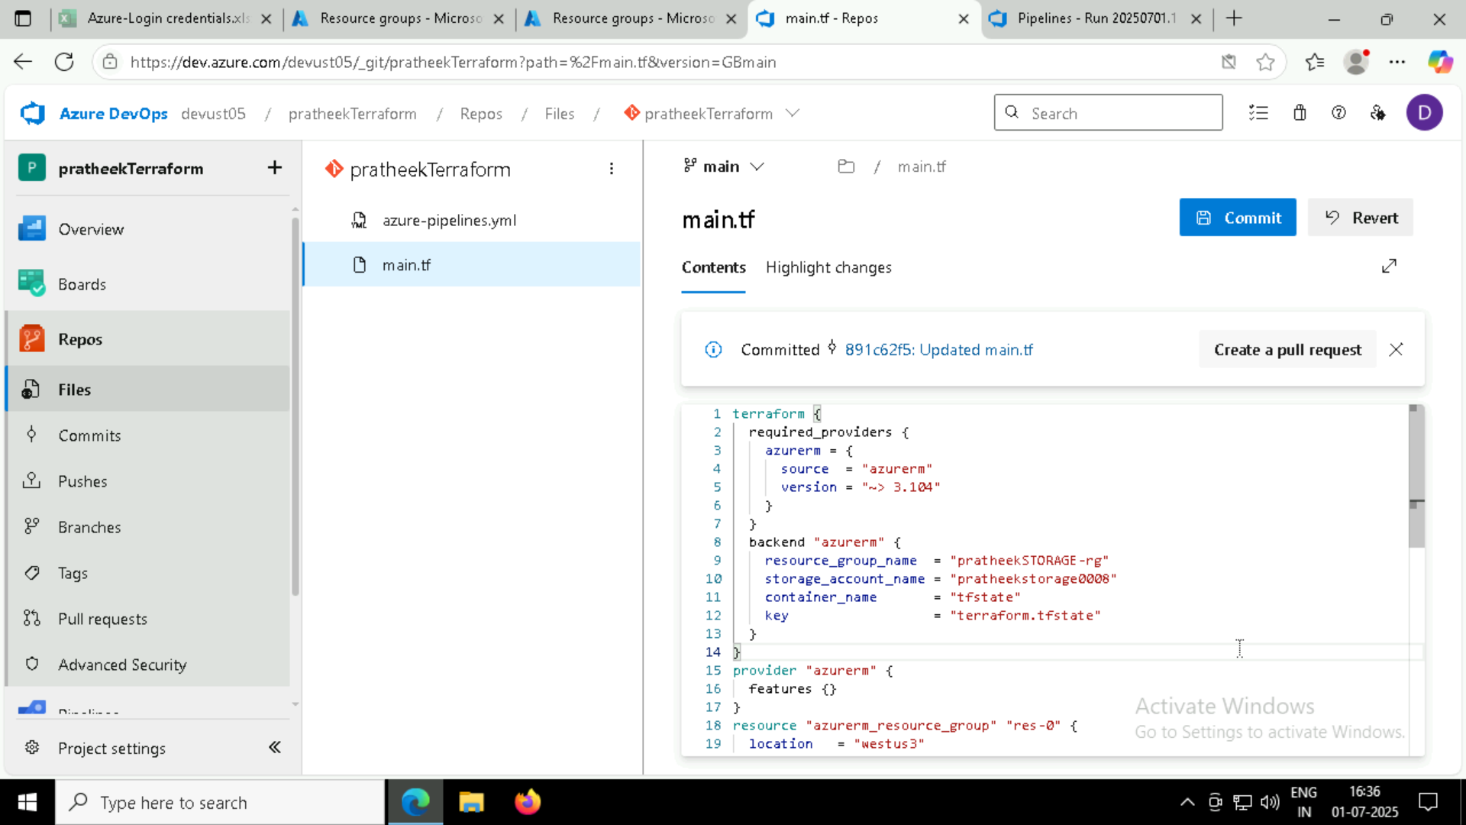

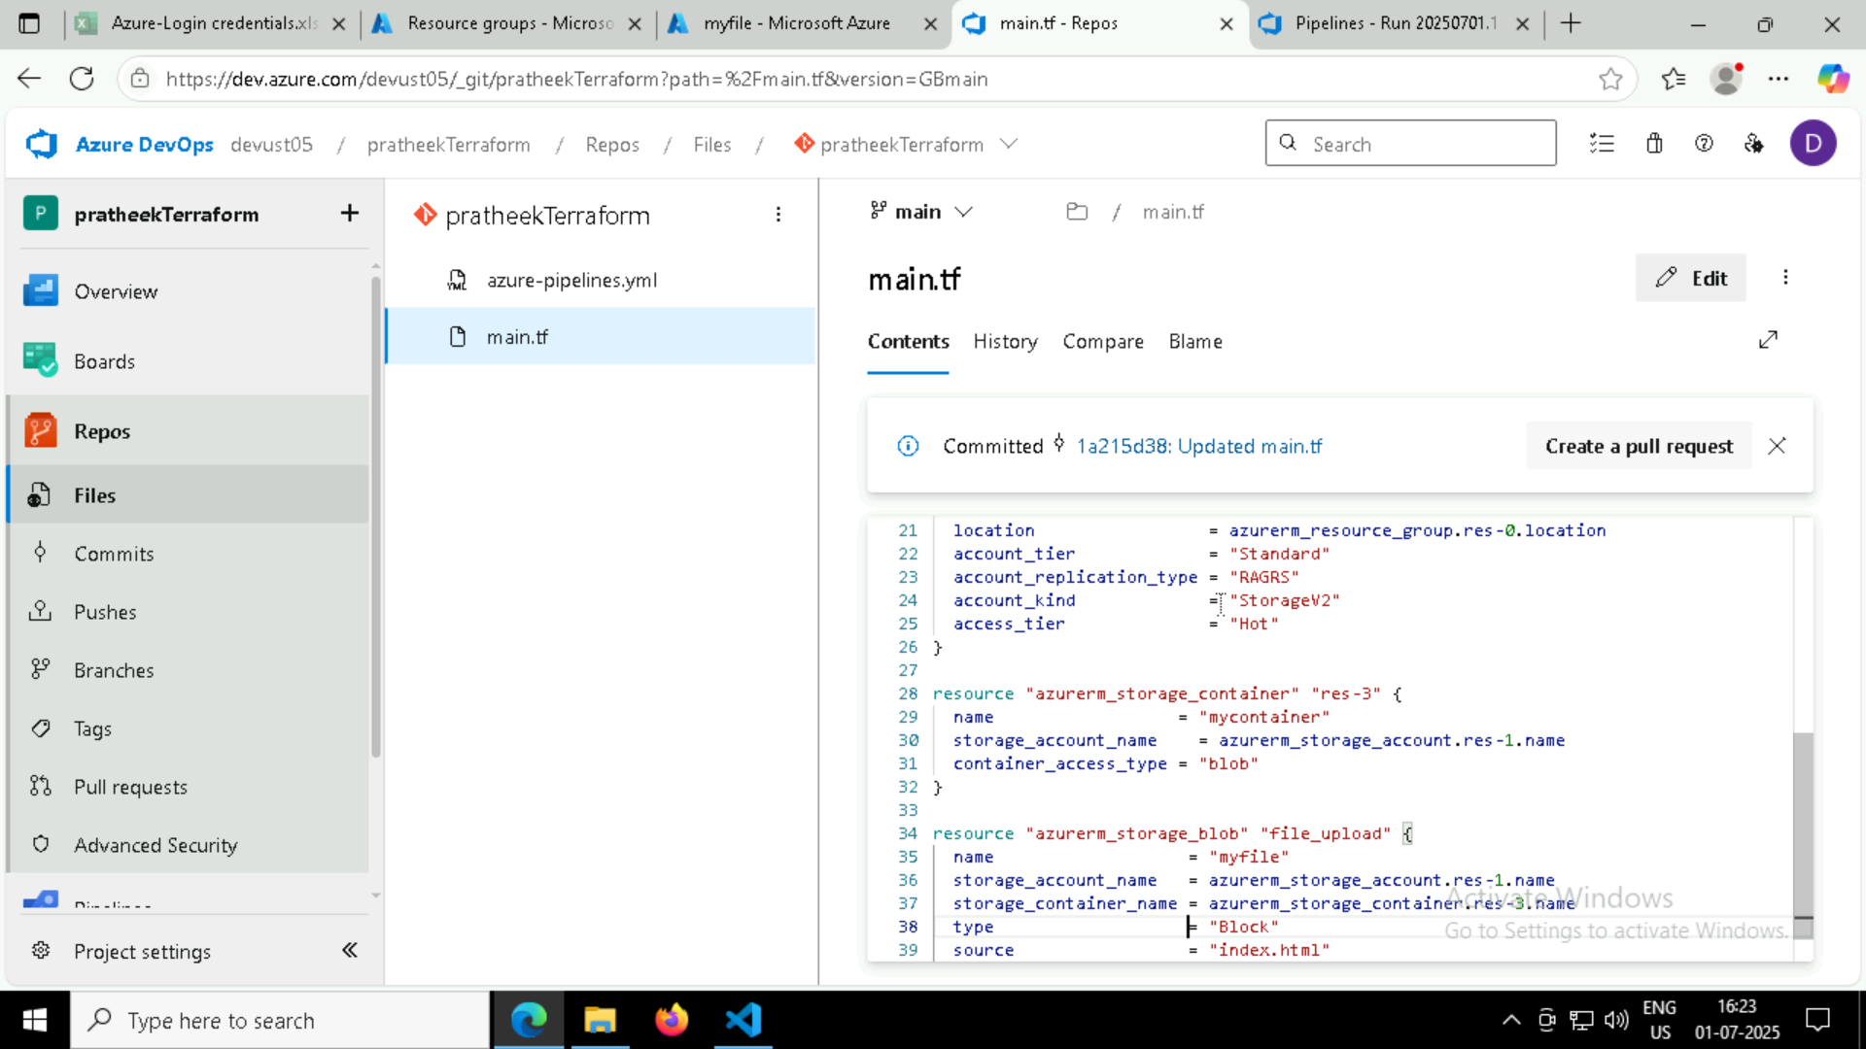

* **My storage account**

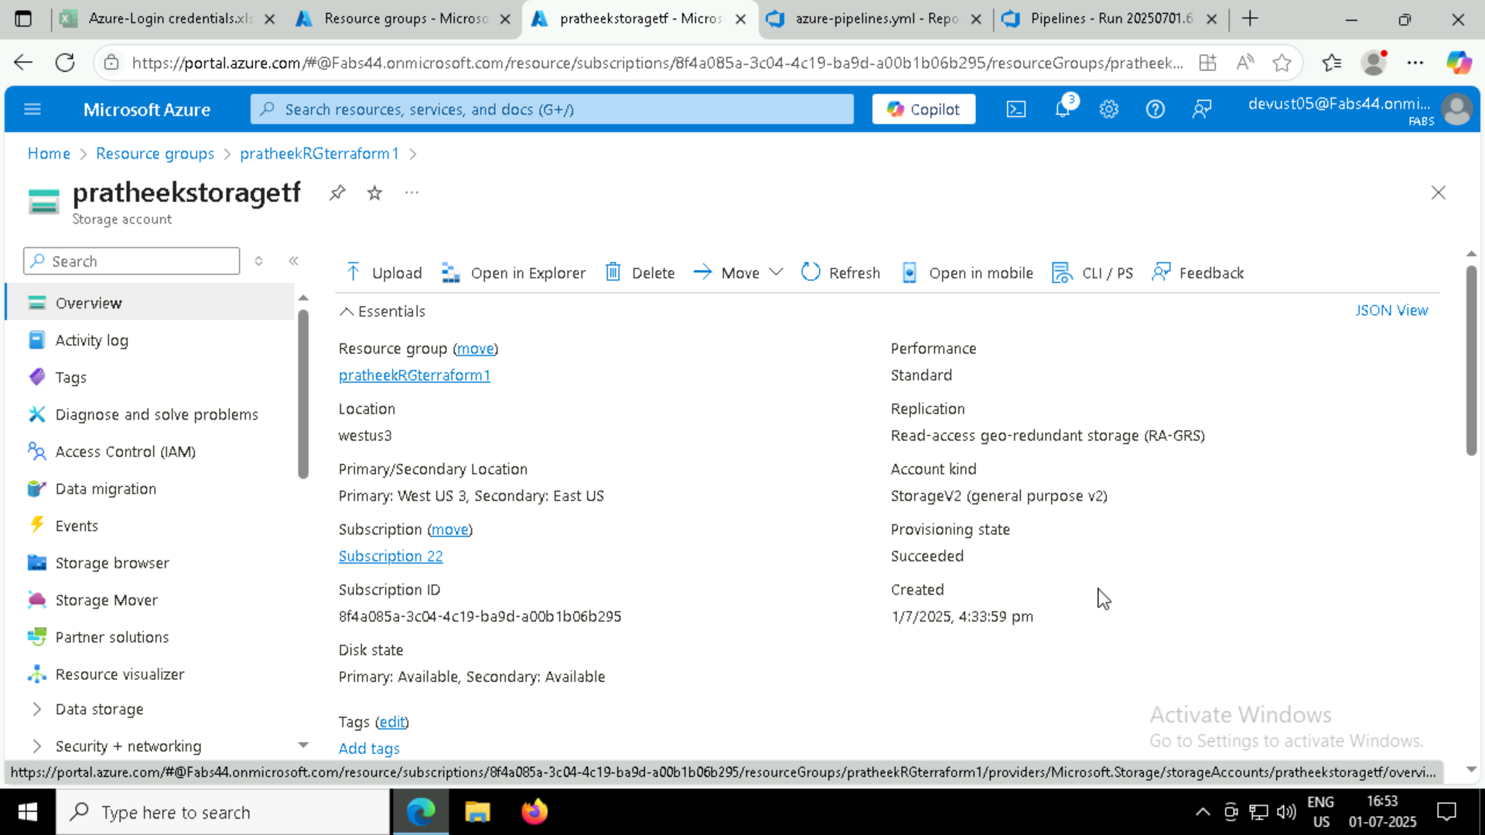

* **Uploading a sample blob**

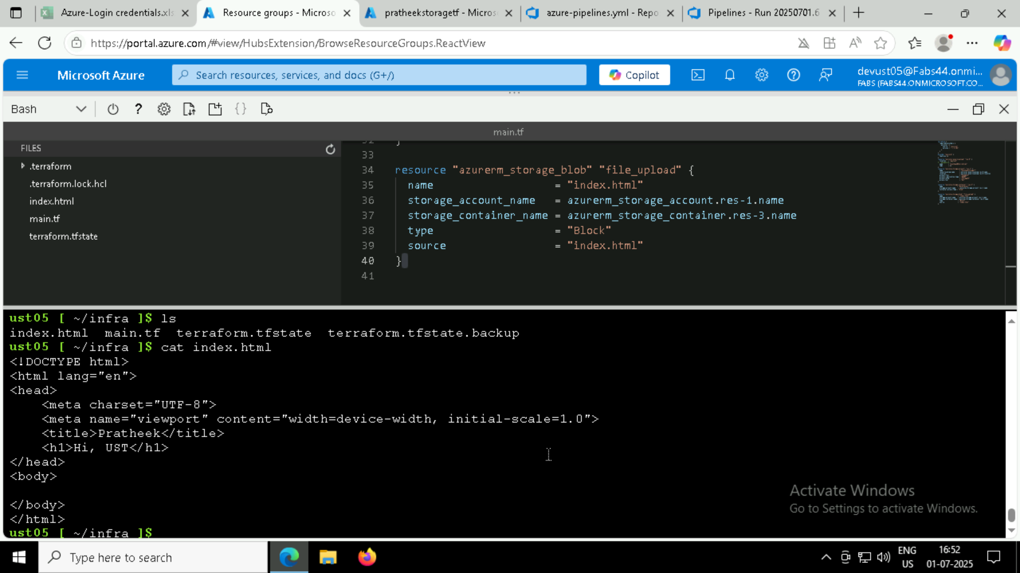

* **Run pipeline:**

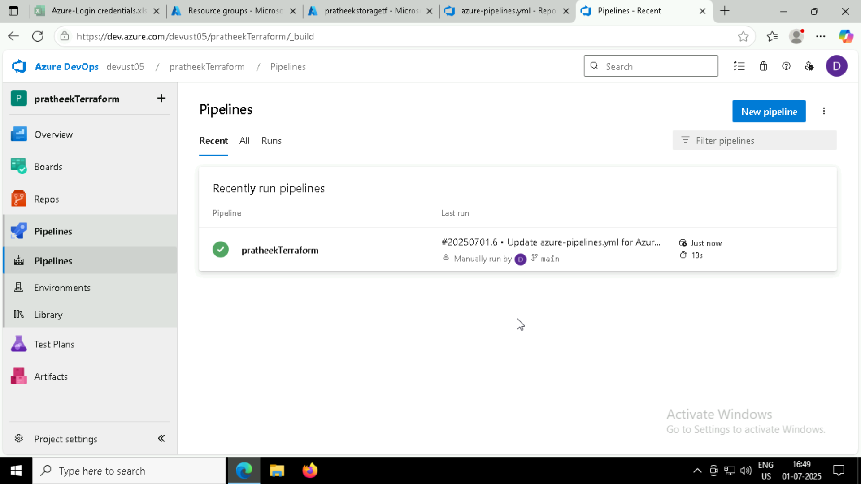

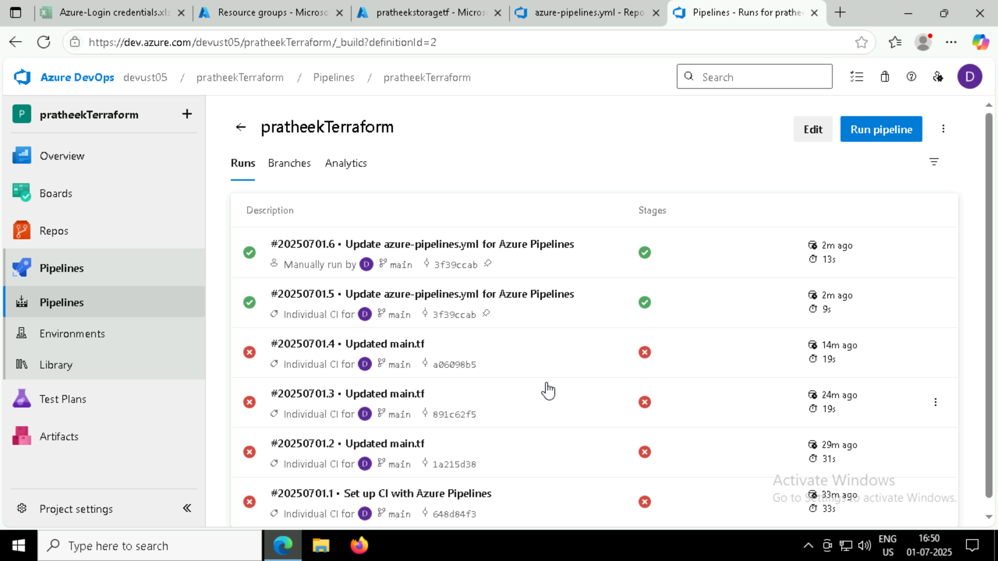

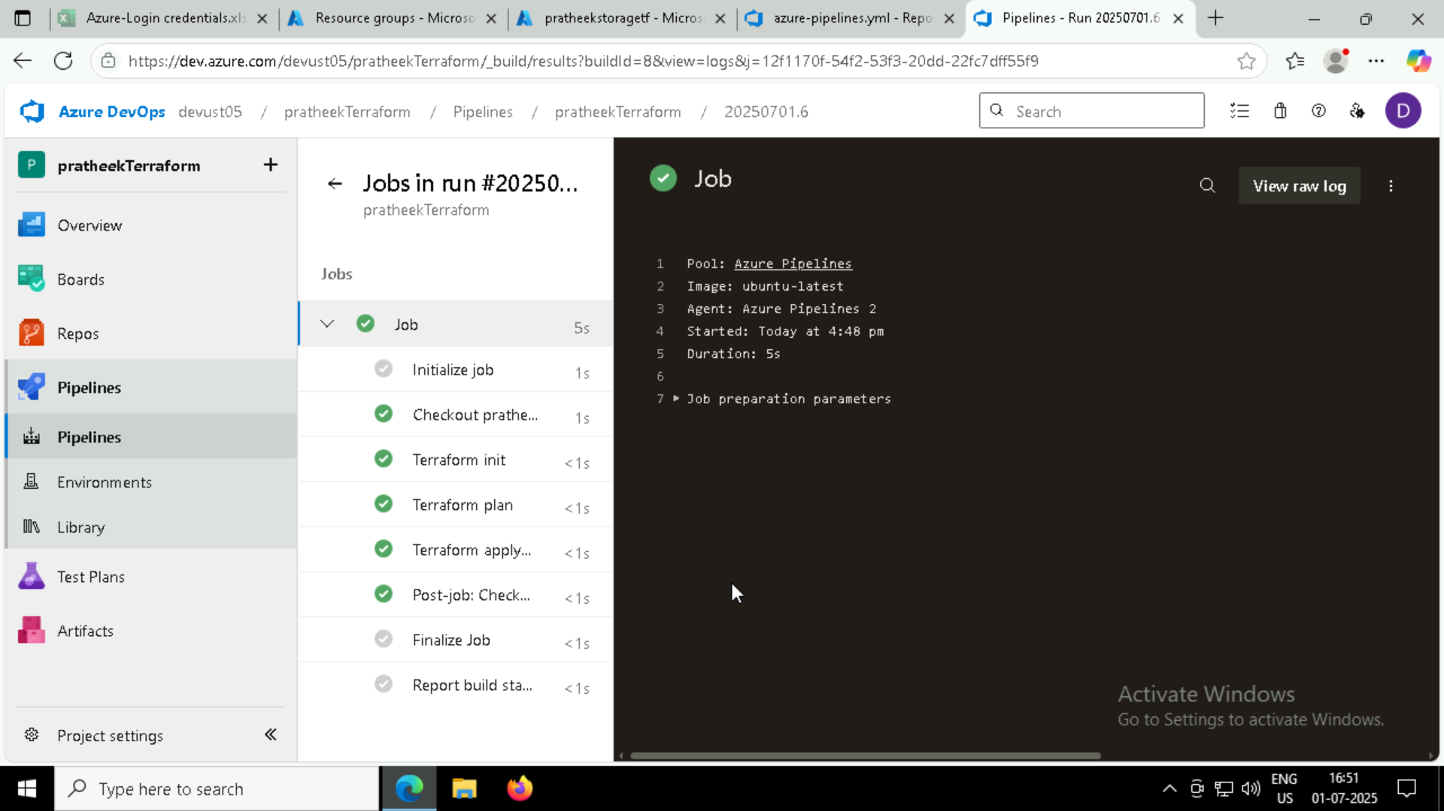

* **Output:**

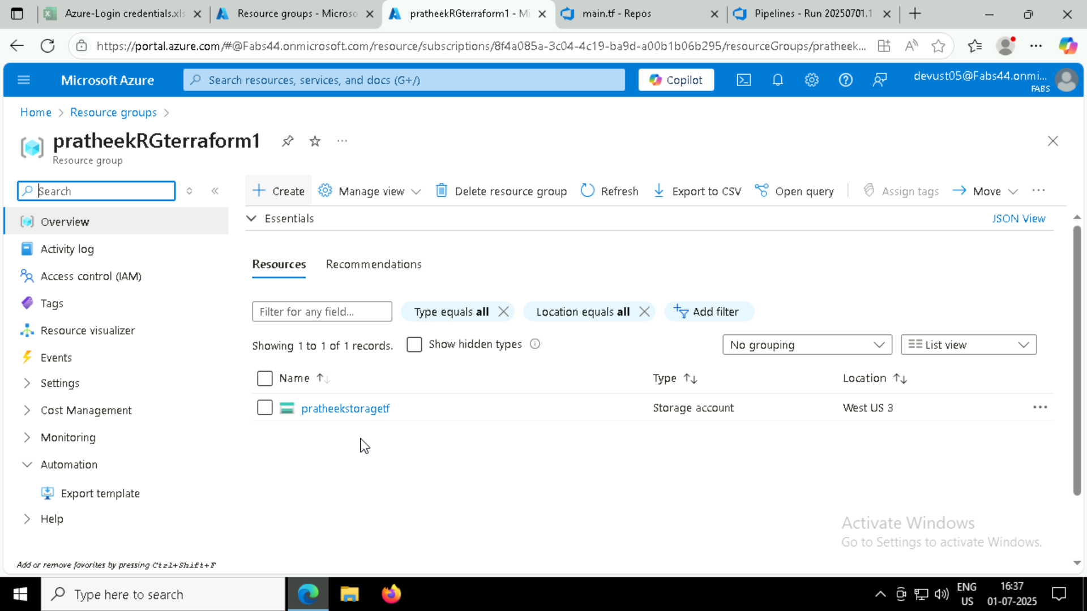

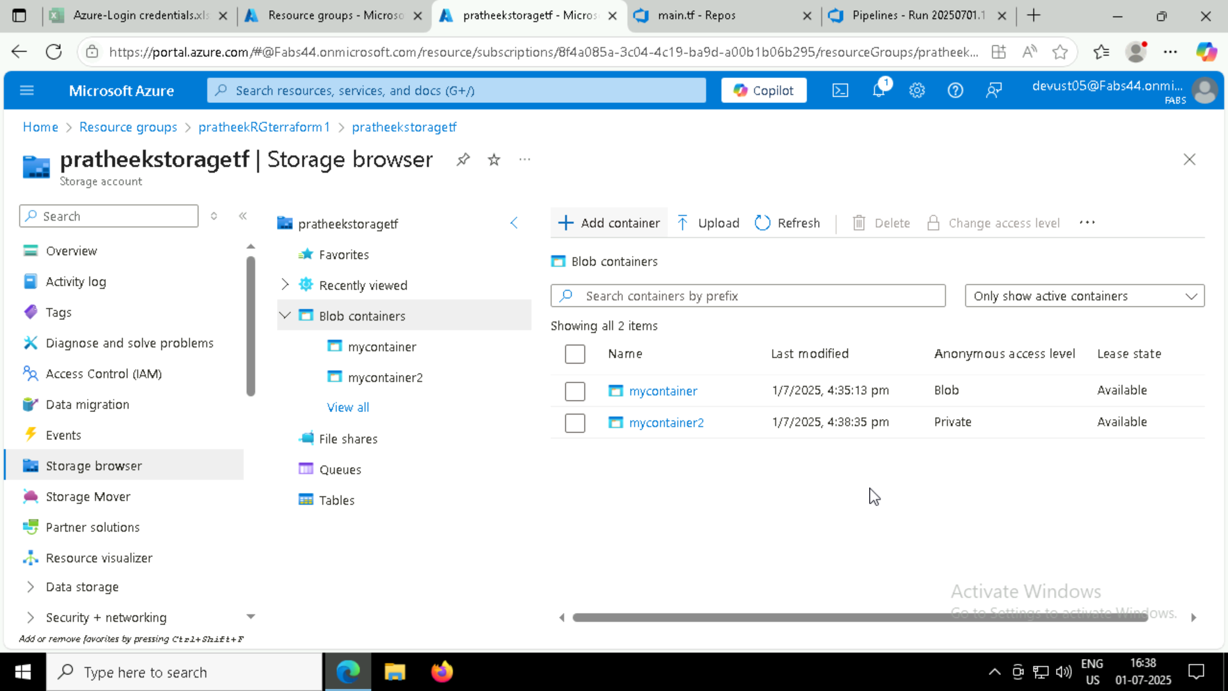

**We can check, the following are created through pipeline script:**

* **Resource group “pratheekRGterraform”**
* **Storage account “pratheekstoragetf”**
* **2 containers “mycontainer” & “mycontainer2” are created**
  + **Which contains blob file which was uploaded**

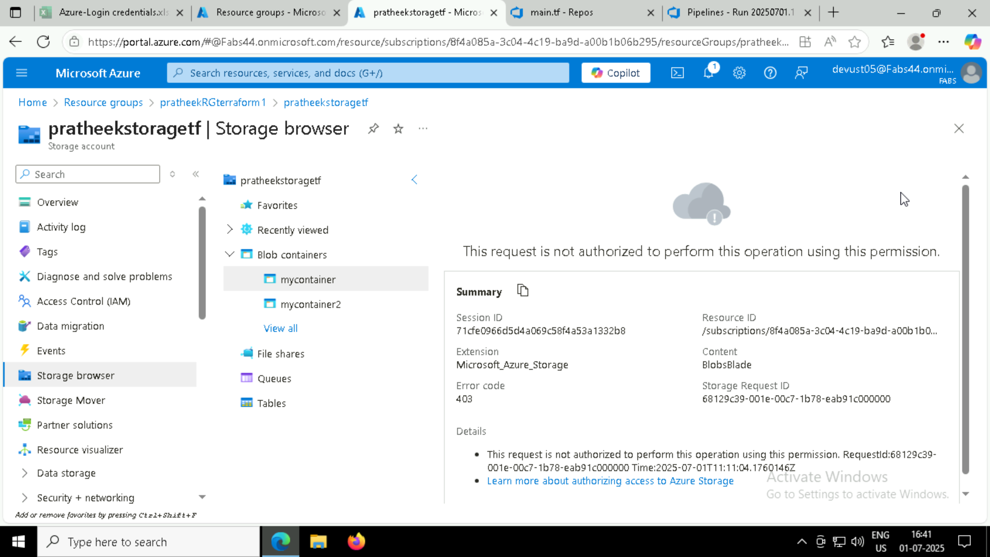

**We can access the file after enabling network rules of my storage account and adding vm’s public ip address:**

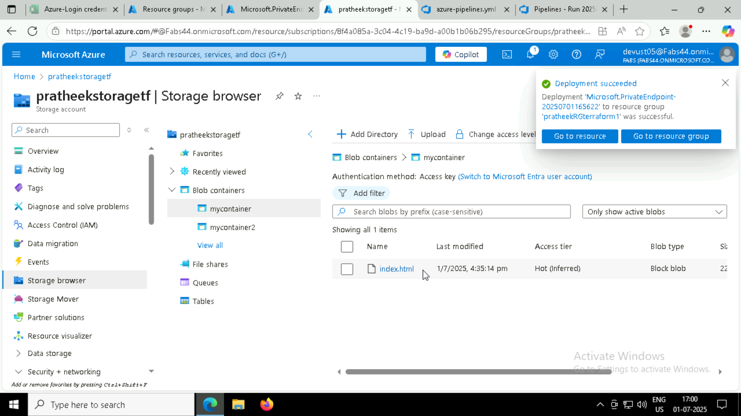

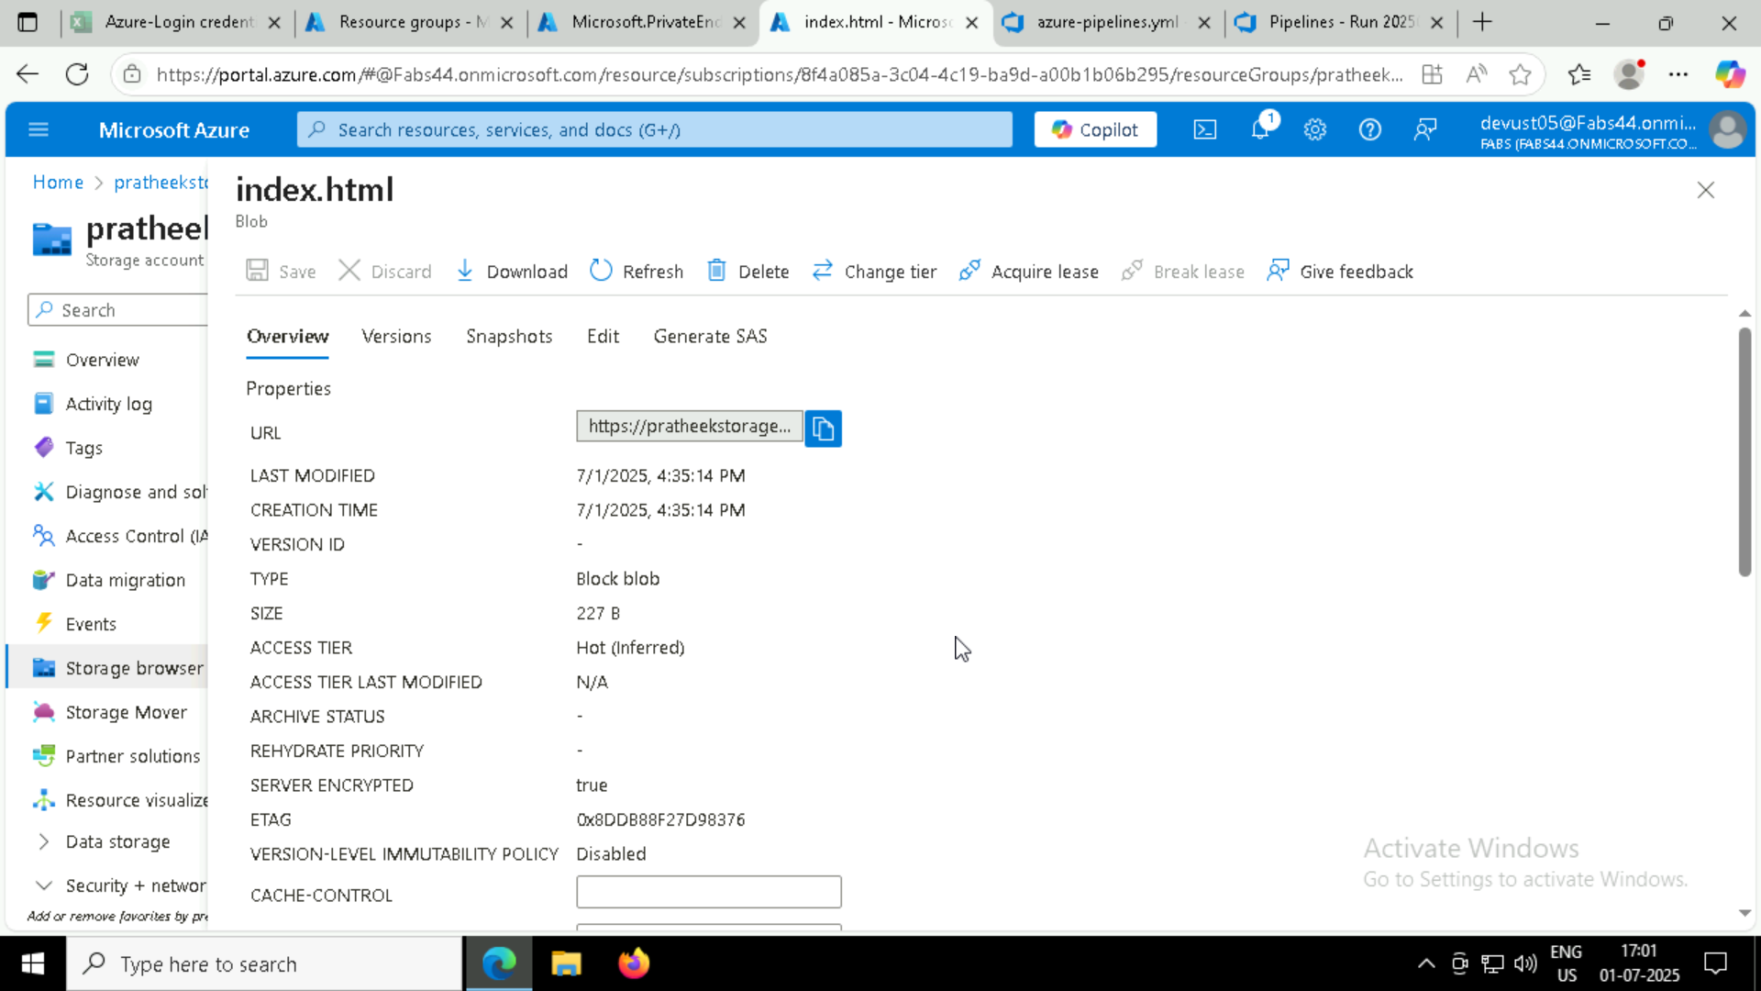

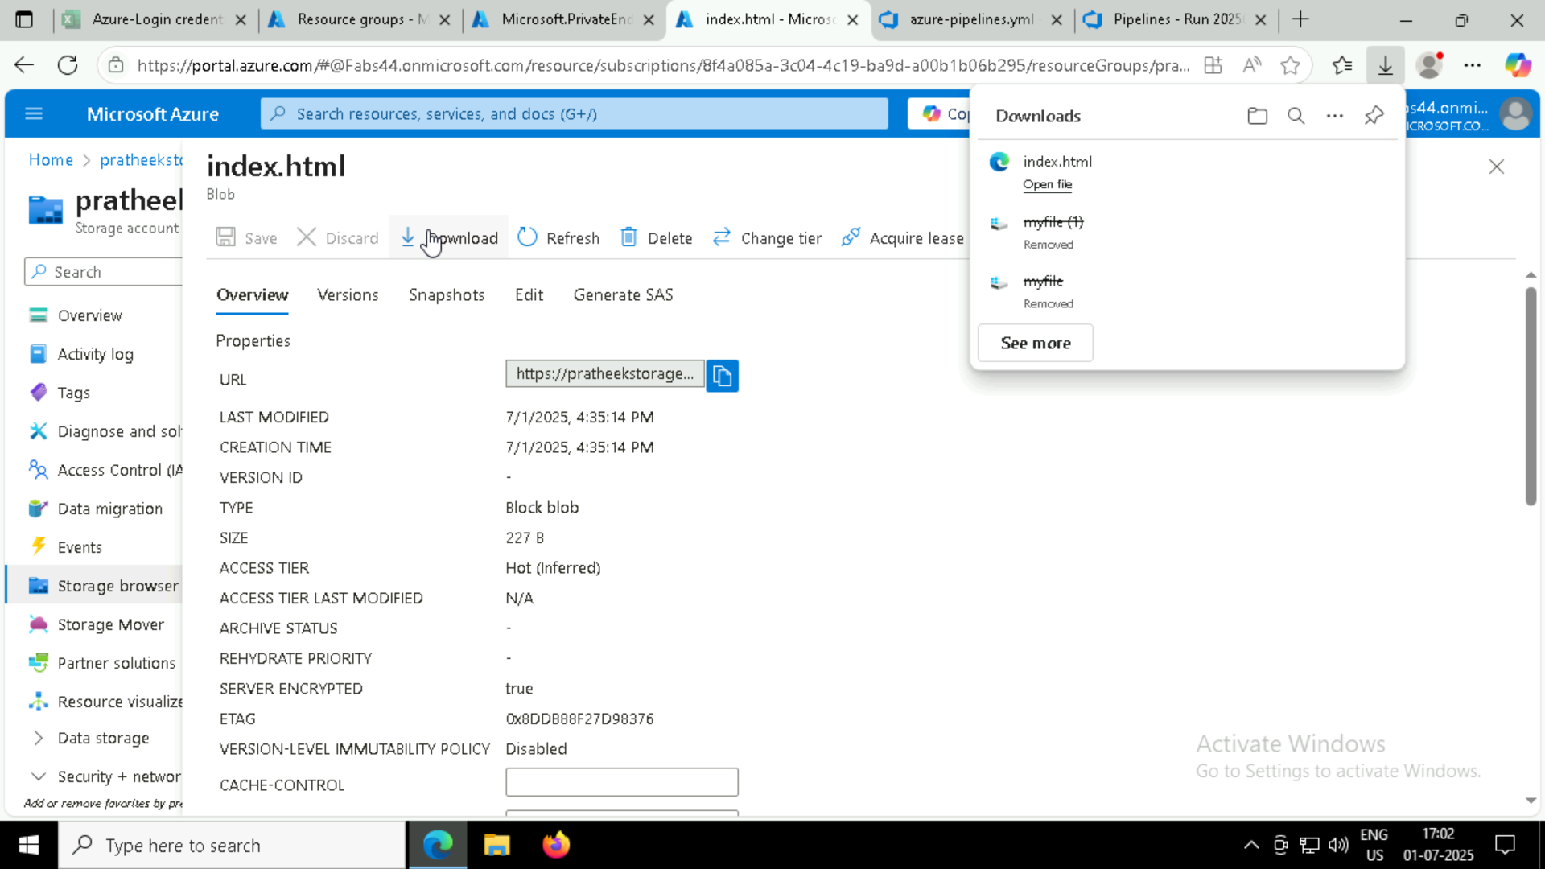

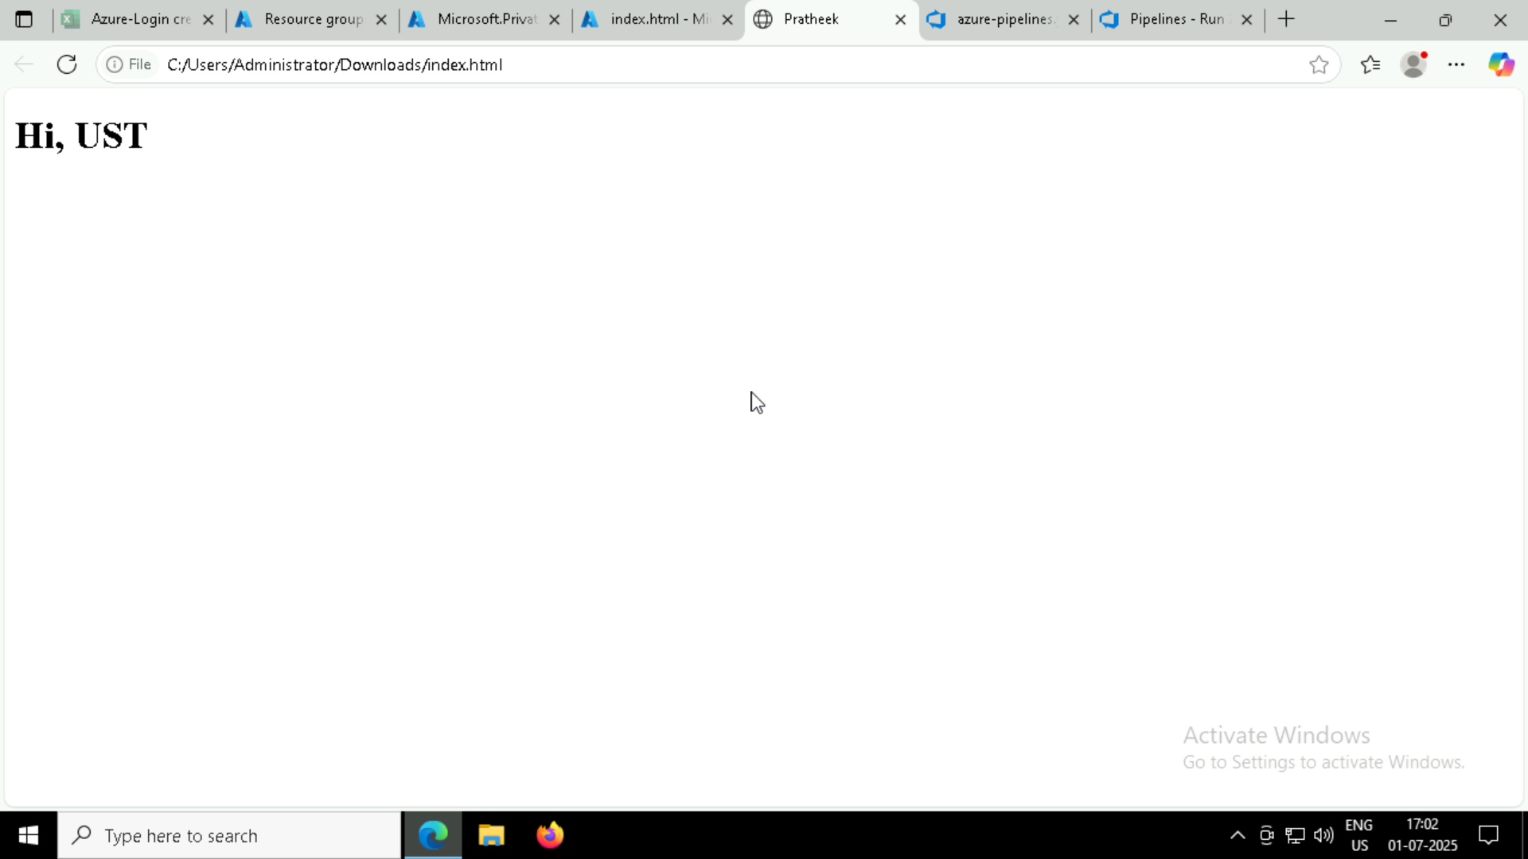

**(I haven’t added service endpoints in my html file then, just executed a trial run)**

**Later created endpoints:**

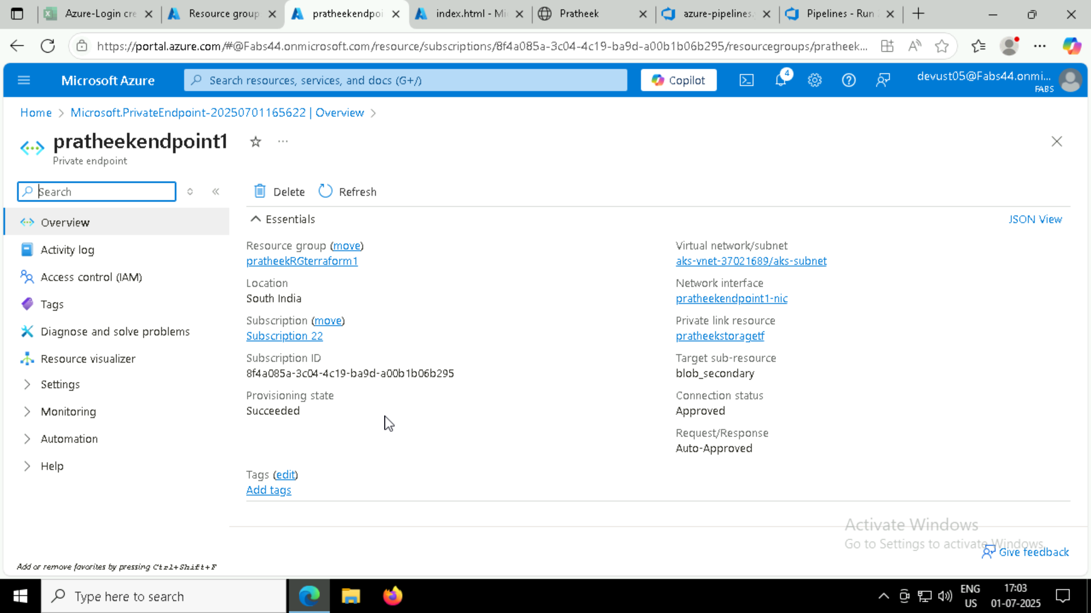

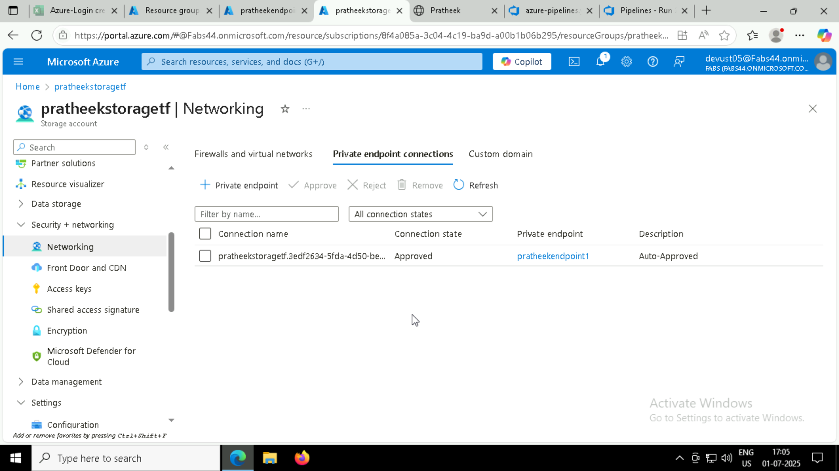

* **Storage account endpoints:**

